Episode 1: Inception
Theory:
1. What is Emmet?
Emmet is a free-add on for your text editor. It allows us to type shortcuts, which are then expanded into full pieces of code. By using emmet, developers type less, hence they save both the keystrokes and time.
Main Definition – Emmet is a plug in for many popular text editors which greatly improves HTML and CSS workflow.

2. Difference between a Library and Framework?
Library – A library is a collection of pre-written code that can be used to perform specific tasks.
Framework – A framework is a set of pre-written code that provides a structure for developing software applications.
We can think that framework is a collection of libraries, but it is entirely different.
By using a library, we can control the flow of the program. The library can be invoked whenever and wherever we like.
A framework instructs us where to put the code, but it will call our code when required.

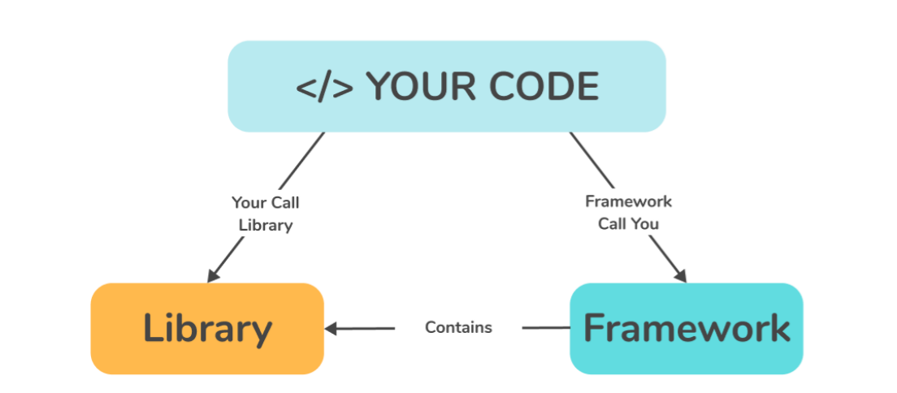
Our code will call the library’s code, but in a framework, it’s the framework’s code that calls our code as shown in the above diagram.

3. What is CDN? Why do we use it?
A Content Delivery Network (CDN) is a group of geographically distributed servers that speed up the delivery of web content by bringing them closer to where users are.
We can also say that Content Delivery Network (CND) is a network of interconnected servers that speeds up webpage loading for data-heavy applications. CDN can stand for Content Delivery Network or Content Distribution Network.

4. Why is React known as React?
React is one of many libraries and it’s completely frontend and specialize in things that the user interacts with when they’re using a website. This could be buttons, search bars and menus. And it’s called React because it reacts.
React is called “React” because of its core features, which is the ability to “React” or respond dynamically to changes in data.

5. What is cross-origin in the script tag?
The crossorigin attribute sets the mode of the request to an HTTP CORS (Cross-origin resource sharing) Request. Web pages often make requests to load resources on other servers. Here is where CORS comes in. A cross-origin request is a request for a resource (E.g.: Style Sheets, iFrames, Images, fonts or scripts) from another domain.
The purpose of crossorigin attribute is used to share the resources from one domain to another domain. Basically, it is used to handle the CORS request. It is used to handle the CORS request that checks whether it is safe to allow for sharing the resources from other domains.
If we serve the React from a CDN, the React documentation recommends to keep the crossorigin attribute set.
6. What is the difference between React and ReactDOM
React library is responsible foe creating views and ReactDOM library is responsible to actually render UI in the browser.
React is a Javascript library for building user interfaces, and ReactDOM is a separate library that is used to interact with the DOM (Document Object Model) in the browser.
React Native is used to build applications that run on both iOS and Android devices.

7. What is difference between react.development.js and react.production.js files via CDN?
In production mode, compression and minification of Javascript and other resources happen to reduce the size of the code which is not the case when it comes to development mode. Performance will be much faster in production mode when compared to development mode.

Production Mode – Optimized performance and reduced bundle size

8. What are async and defer?
Async – Async allows your script to run as soon as it is loaded, without blocking other elements on the page.
Defer – Defer means your script will only execute after the page has finished loading.
Defer is used for scripts that need the whole DOM and/or relative execution is important -> Guarantees the order of execution of script
Async is used for independent scripts, like counters or ads and their relative execution order does not matter -> Does not guarantees the order of execution of script.

9. What is the difference between Attributes and Properties?
The primary difference between HTML attributes and properties is their purpose. HTML attributes are used to define the characteristics of an HTML element, such as its appearance, while HTML properties are used to define the internal behaviour and functionality of an HTML element.
Attributes are defined by HTML, but properties are defined by DOM.

Coding:
Set up all the tools on your laptop
- VS Code
- Chrome
- Extensions of Chrome
Create a new Git repo
Build your first Hello World program using,
- Using just HTML
- Using JS to manipulate the DOM
- Using React
use CDN Links
Create an Element
Create nested React Elements
Use root.render
Push code to Github (Theory as well as code)
Learn about Arrow Functions before the next class
References:
- https://github.com/namastedev/namaste-react
- https://www.youtube.com/watch?v=IrHmpdORLu8

